MACHINE LEAENING CLASSIFICATION

EVALUATION METRICS USING PARAMETERS

Accuarcy:

Correct classsified of both /correct + incorrect classsified of both class

Accuracy means total percentage of the correct classified of Every class to sum of the correct and incorrect classified of Every class .

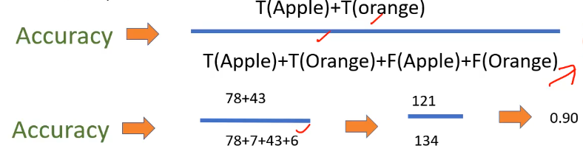

Recall:

Correct classsified of class/ correct + incorrect classsified of class

Recall means total percentage of the correct classified class to sum of correct and other incorrect classified of class or total input of the datset

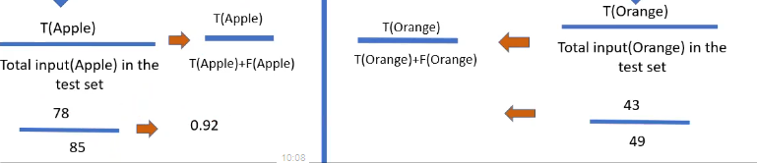

Precision:

Correct classsified of class/ Correct classsified class+ incorrect classified of other class

Precision means total percentage of the correct classified class to sum of the correct classified perticular class and other incorrect classified class

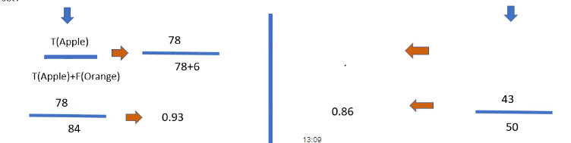

F1-Measure:

If recall and precision both dont have high values means, we can use ths f1 measur for checking the perfomance of both

Total class multiplecation with Multiplecation of total percentage of recall and precision to sum of total percentage of recall and precision of the perticular class

F1 measure =2\*(recall\*precision/ recall+precision)

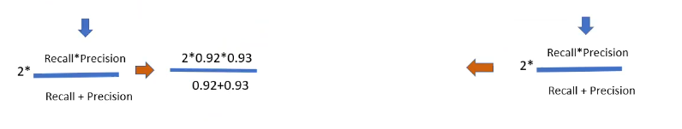

Macro Average:

We are going to find the macro averagefor precision and recall, and f1 measure

Macro average means sum of all class precision value to the class count

Precison (apple)+precision(mango)+etc/count of the class

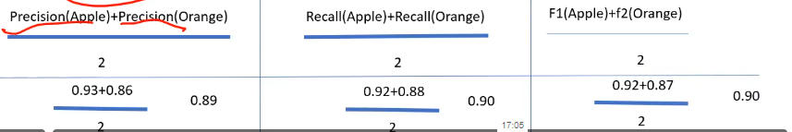

Weight Average:

We are going to find the macro averagefor precision and recall, and f1 measure

Weight average for precision means total percentage of precision to sum of total count of the perticular class divided by total count of the dataset

Precision(apple)\*(total count of apple /total cout of dataset)+ Precision(orange)\*(total count of orange /total cout of dataset)

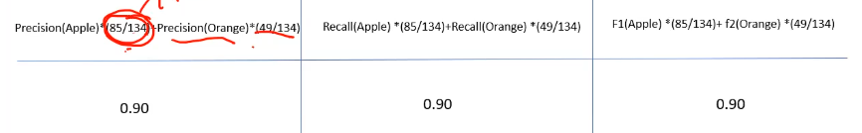

QUESTION ABOUT PARAMETERS OF CLASSIFICATION:

1.what is the over all perfomance of the module: Accuracy value 0.87

2. what is the correct classification of not purchased (0): recall value of not purchased(0) 0.89

3. what is the correct classification of purchased (1):recall value of purchased(1) 0.84

4.what is the precision value of not purchased(0): precision value of not purchased(0)0.90

5. what is the precision value of purchased(1): precision value of not purchased(1)0.82

6. what is the total count or both correct and incorrect classified class : 134

7. support value of the purchased(1): total count of the purchased(1)49

8. support value of the not purchased(0): total count of not purchased(0)85

9.what is the macro average of recall : 0.87

10. what is the weight average of precision:0.87 